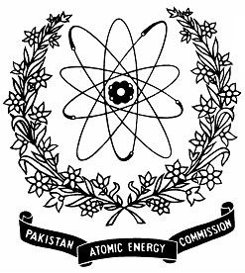 | Nuclear Institute for Agriculture and Biology (NIAB), Faisalabad, PAKISTAN

14thTRAINING COURSE ON “BIOCHEMICAL AND MOLECULAR TECHNIQUES IN PLANT BREEDING” (Nov. 10-14, 2025)

Application Form
Name  Father’s Name  CNIC# (Please also attach two attested photocopies) |  |  | Photos  (2 in Number)
Please select appropriate

Student Researcher/Faculty
Qualification | Name of Institution and address
Designation

Mailing Address

Email Cell No. (compulsory)
Signature of the Applicant |  | Recommendation of Head of Institute/Department  -----------------------------------------  Signature
Particular interest for training

Note:- Last date for submission of application is November 04, 2025. Please attach Demand Draft of registration fee in fovour of “Head LAO NIAB”.
Advance copy of application can be sent by email to: amjad46pk@yahoo.com

