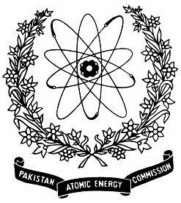 | Nuclear Institute for Agriculture and Biology (NIAB), Faisalabad, PAKISTAN

7th WORKSHOP ON SCIENTIFIC WRITING (April, 01-02, 2026)

Application Form
Name  Father’s Name  CNIC# (Please also attach 2 attested photocopies) |  |  | Photos  (2 in Number)
Please select appropriate

Student Researcher/Faculty
Qualification | Name of Institution and address
Designation

Mailing Address

Email Cell No. (compulsory)
Signature of the Applicant |  | Recommendation of Head of Institute/Department  -----------------------------------------  Signature
Particular interest for training

Note:- Last date for submission of application is March, 25., 2026. Please attach Demand Draft of registration fee in fovour of “Head LAO NIAB”.
Advance copy of application can be sent by email to: amjad46pk@yahoo.com

