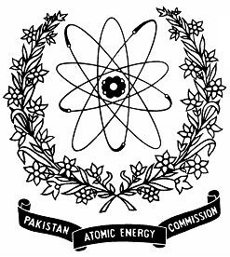 | Nuclear Institute for Agriculture and Biology (NIAB), Faisalabad, PAKISTAN

TRAINING WORKSHOP ON “ADVANCEMENT IN BIOSALINE AGRICULTURE TECHNOLOGY FOR FOOD SECURITY IN PREVAILING CLIMATE CHANGE SCENARIO” (22 – 23 OCTOBER, 2025)
Application Form

Name  Father’s Name  CNIC# (Please also attach two attested photocopies) |  |  | Photos  (2 in Number)
Please select appropriate

Student Researcher/Faculty
Qualification | Name of Institution and address
Designation

Mailing Address

Email Cell No. (compulsory)
Signature of the Applicant |  | Recommendation of Head of Institute/Department  -----------------------------------------  Signature
Particular interest for training

Note:- Last date for submission of application is October 21, 2025.
Advance copy of application can be sent by email to: arawan77@yahoo.com

